Database and file Management Systems (CIS 2109)

Homework 07

1. Whitlock Department Stores runs a multiuser DBMS. Unfortunately, at the present time, the DBMS does not enforce concurrency control. One Whitlock customer had a balance due of $500 when the following three transactions related to this customer were processed at about the same time:
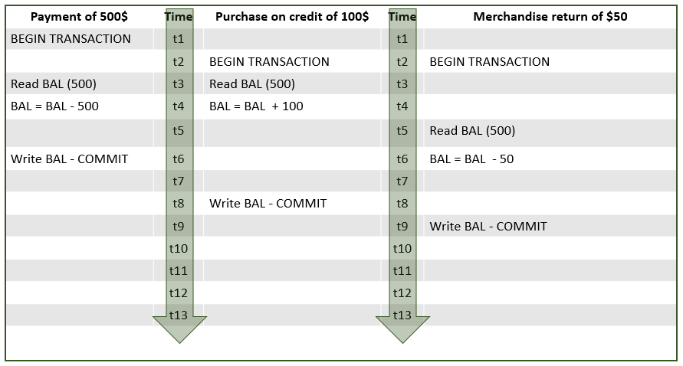
Each of the three transactions read the customer record when the balance was $500 (i.e., before any of the other transactions were completed and execute according to the timeline shown in the above figure.
a. What balance will be included for the customer after the last transaction was completed?
b. What balance should be included for the customer after the three transactions have been processed?
c. Assume that only the first two transactions are executed and also assume that now the database enforces serializability using the two-phase locking mechanism. Illustrate what the process will be. Do any deadlocks occur?
d. Now assume that only the first and the last transactions are executed and also assume again that the database enforces serializability using the two-phase locking mechanism. Illustrate what the process will be. Do any deadlocks occur?
e. If versioning is used as concurrency control mechanism, what will happen? What will the final balance be?

2. Consider the following normalized relations for a sports league and assume that the database is global in scope and covers thousands of leagues, tens of thousands of teams, and hundreds of thousands of players.
TEAM(TeamID, TeamName, TeamLocation, TeamManager, TeamLeague)
PLAYER(PlayerID, PlayerFirstName, PlayerLastName, PlayerDateOfBirth, PlayerSpecialtyCode, TeamId)
SPECIALTY(SpecialtyCode, SpecialtyDescription, Salary)
LOCATION(LocationID, CityName, CityState, CityCountry, CityPopulation)
MANAGER(ManagerID, ManagerName)
LEAGUE(LeagueID, LeagueName, LeagueLocation)
- Do you see any denormalization opportunities?
- What are the first steps that you can take to improve the performance of the database?
- Specify the types of indexes you would recommend for each of the following situations:
- Reporting players by team using the team name
- Reporting players of a specific specialty using the specialty code. How is your answer different if the report is using specialty description as input?
- Reporting the players whose salary is above a specific value.
- Reporting teams and their players by city
- Do you see any partitioning opportunities based on the above queries?

3. Assume that a DBMS has the transactions Q, R, S and T with the timeline depicted in the figure being executed.
You can also assume that:
- Transaction Q updates the value of x from 0 to 20
- Transaction R updates the value of y from 1 to 5
- Transaction S updates the value of z from 8 to 12
- Transaction T updates the value of w from 2 to 20
- A checkpoint is written at timepoint t4
- The DBMS crashes at timepoint t6.

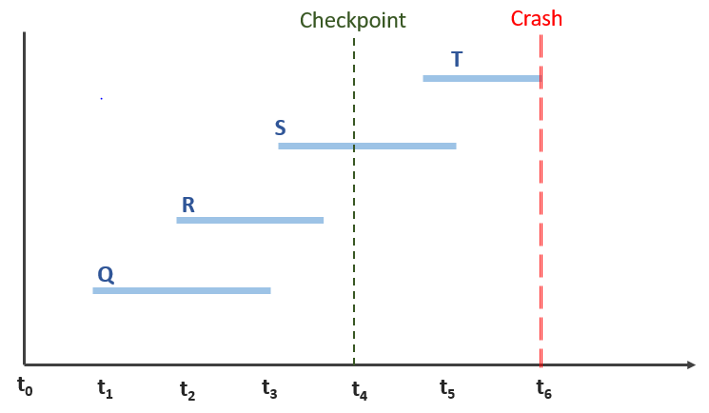
Now answer the following questions:
- Which transactions, if any, need to be redone?
- Which transactions, if any, need to be undone?
- Which transactions, if any, are not affected by the crash?
- What will the final value of x,y,z and w be?

